Overall Positioning Summary
Capability Area | watsonx.workshop | AskSales
Core Role | Pipeline execution | Strategic sales guidance
Strength | Structured outputs, repeatable workflows, simulates real sales conversations | Contextual insights, business narrative
Best Use | Building pipeline assets (use cases, discovery, practice) | Shaping deals, positioning, and messaging
Limitation | Less strategic, depends on inputs | Less hands-on pipeline building
AskSales helps determine the story.
Watsonx.workshop helps build and practice the story.

Watsonx.workshop Tutorial 1: Client Insights & Entry Points
- Launch a new session → select Client Insight Agent
- Input:
  - Opportunity ID (preferred)
  - OR upload account docs / LinkedIn profiles
- Add:
  - Product focus (e.g., watsonx, data, AI)
- Run prompts:
  - “Summarize account priorities”
  - “Identify AI opportunities”
  - “Generate discovery questions”

Watsonx.workshop
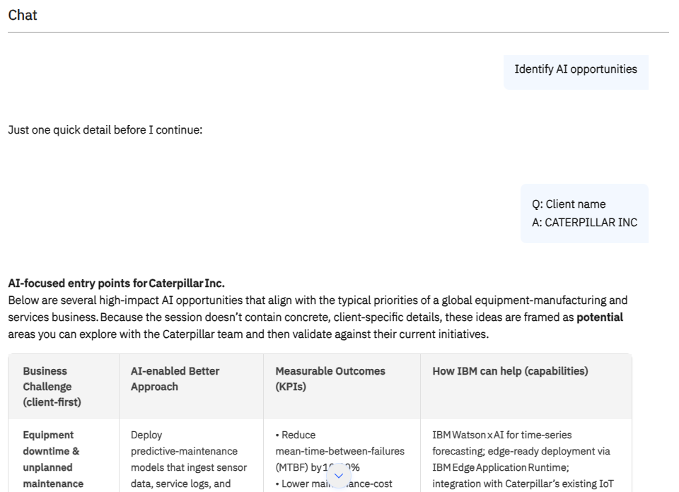
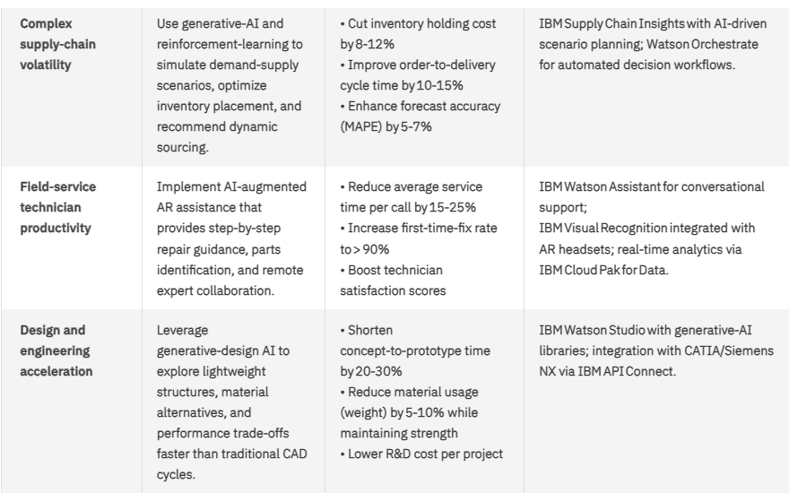
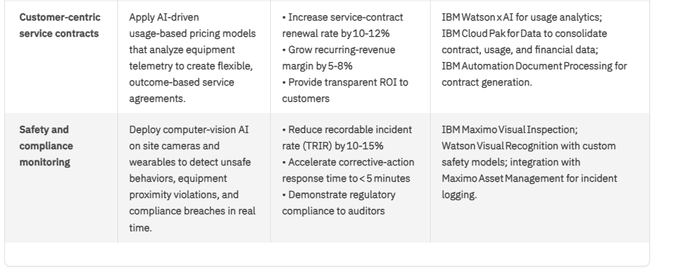
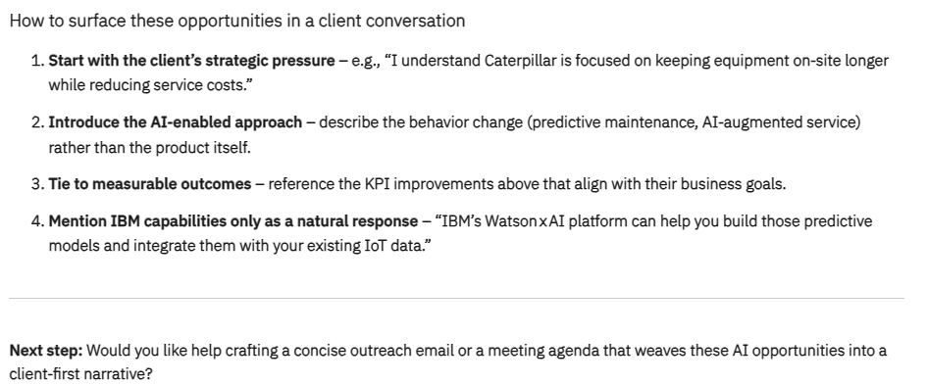

AskSales
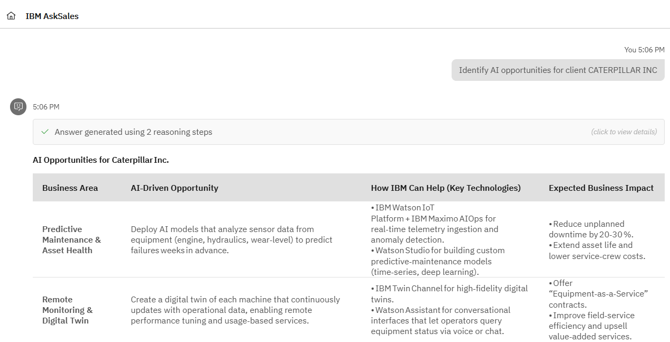
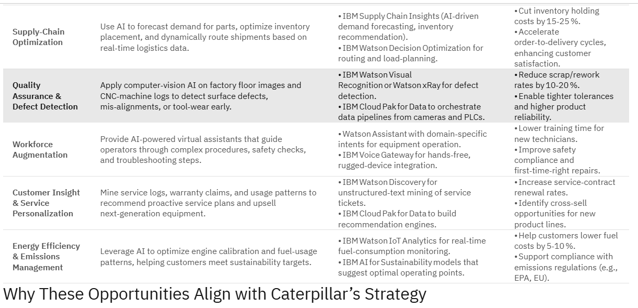
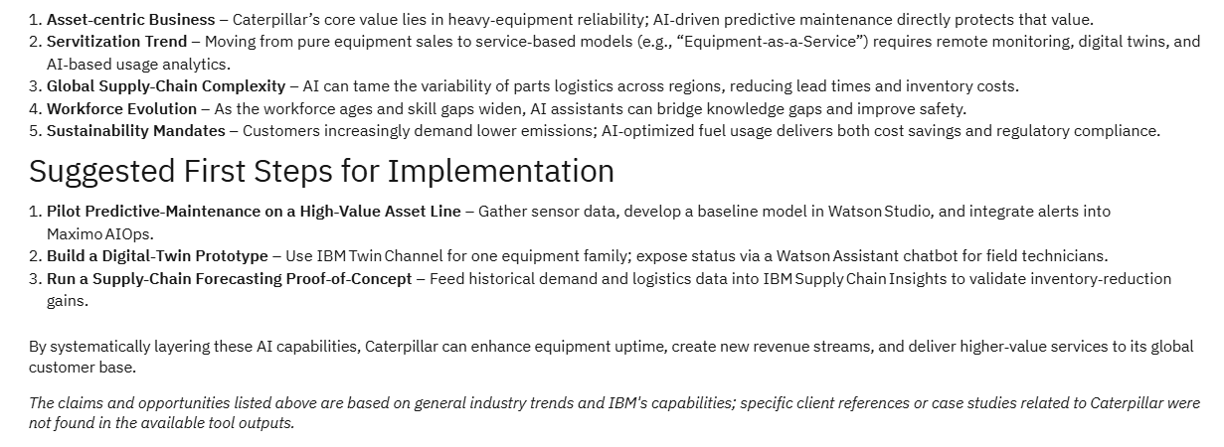

Comparison

watsonx.workshop
What it DOES well
- Turns explicit inputs → structured outputs, e.g.:
  - Account priorities listed cleanly
  - AI opportunities broken into categories
  - Discovery questions generated in bulk
- Forces seller to think in a repeatable workflow:
  - Input → Prompt → Output → refine
- Discovery questions are practical and usable immediately in calls
Where it falls short
- Outputs are surface-level and pattern-based
  - e.g., priorities tend to be generic (“cost optimization,” “digital transformation”)
- Requires manual prompting for each step
  - Doesn’t auto-progress from insight → strategy
- No clear prioritization of opportunities
- Doesn’t explain why these insights matter to the client’s business context

AskSales
What it does better
- Provides more synthesized account understanding
  - Connects priorities → business drivers → IBM positioning
- Less prompt-dependent — feels more like guided insight generation
- Outputs show clearer narrative flow, not just lists

Conclusion: watsonx.workshop generates inputs for pipeline creation, but AskSales starts shaping account strategy

Watsonx.workshop Tutorial 2: Build Pipelines w/ Products
Goal: Turn insights into a solution narrative
Steps
- Use Sales Pipeline / Use-Case Agent
- Input:
  - Customer context
  - Industry
- Generate:
  - “Top 3 AI use cases”
  - “Value proposition for CFO / CIO”
- Refine:
  - Add product alignment (watsonx.ai, governance, data)
Output:
- Use-case hypothesis
- Business value mapping
- Suggested solution architecture

Watsonx.workshop
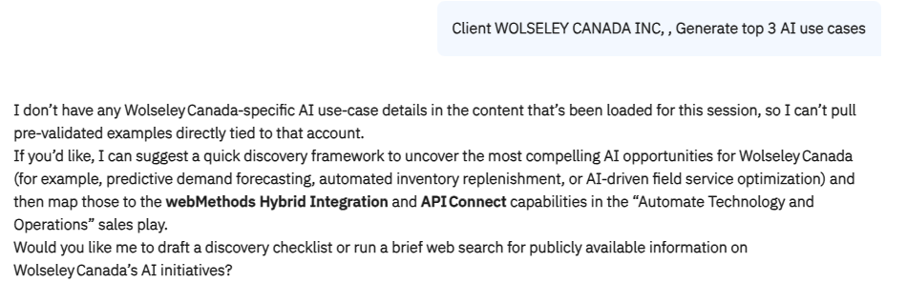

AskSales
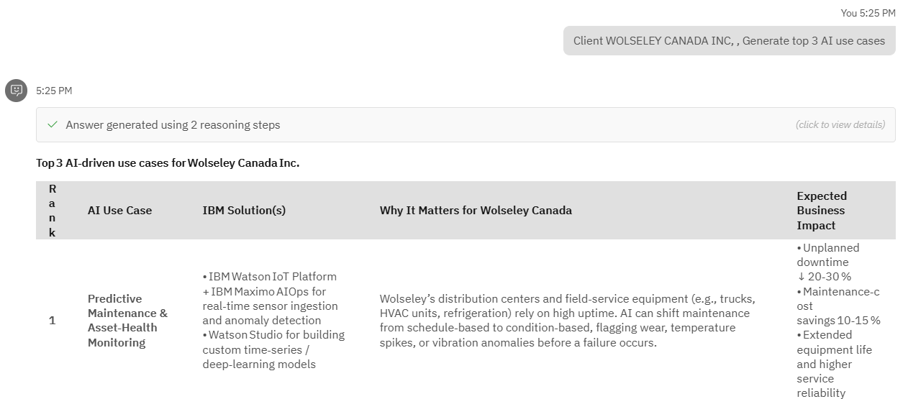
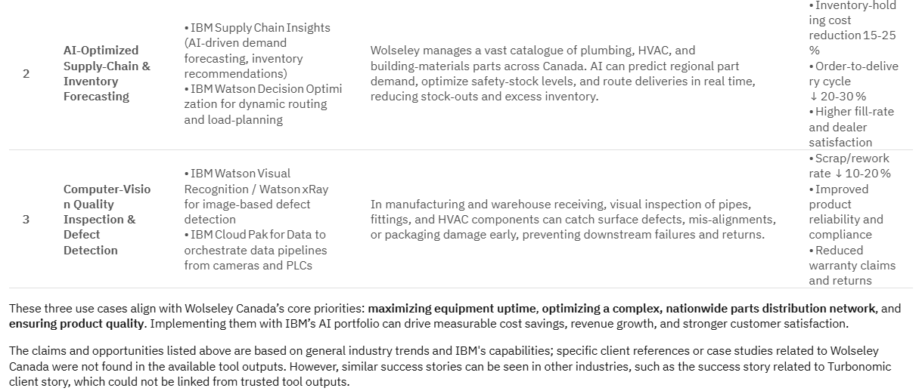

Comparison

watsonx.workshop
What it DOES well:
- Very strong at assembling pipeline assets quickly
  - Use cases clearly structured
  - Value props tied to roles (CFO/CIO)
  - Architecture suggestions included
- Good at mapping IBM products to use cases
  - watsonx.ai, governance, data integration
- Output is modular and reusable
  - Easy to copy into a deal doc / pitch
Limitations:
- Use cases are often templated
  - Similar structure regardless of industry nuances
- Value props are functional, not compelling
  - e.g., “improves efficiency” vs. quantified business impact
- Architecture is high-level
  - Not tailored to real client constraints
- No sense of deal strategy
  - Doesn’t say which use case to lead with or why

AskSales
What it does better:
- Frames use cases in business outcomes
  - Revenue, cost, risk (not just features)
- Helps answer:
  - “Why this use case first?”
  - “Why IBM over competitors?”
- Produces stronger executive-ready messaging
Conclusion: watsonx.workshop is pipeline builder (assets); AskSales is deal strategist (story + prioritization)

Watsonx.workshop Tutorial 3: Learn IBM Products
Goal: Build technical credibility by mastering technology domains and IBM products so you can speak confidently with clients and partners.
- Launch a new session → select Learn IBM Technology
- Type in prompts
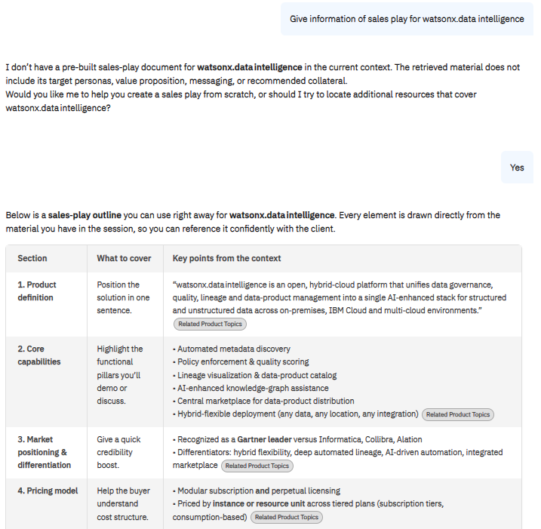

AskSales
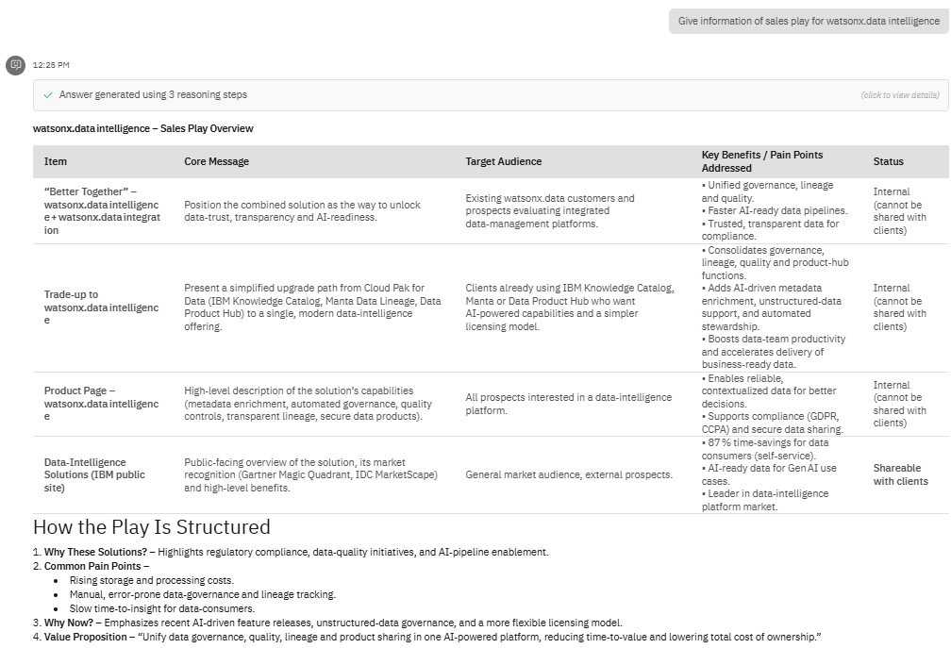
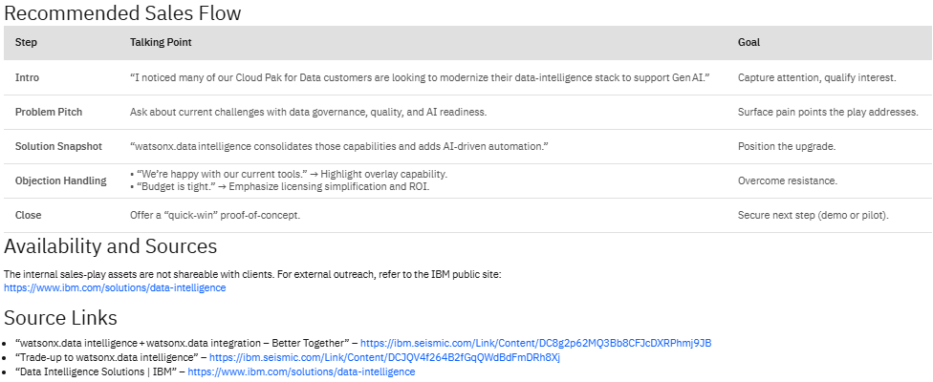

Comparison

watsonx.workshop
What it DOES well:
- Provides structured, foundational explanations of IBM products
  - Capabilities
  - Components
  - General use cases
- Good for learning product basics quickly
- Consistent format makes it useful for self-paced enablement
Limitation (Observed in your example):
- Cannot reliably retrieve or reflect existing IBM sales plays
- When asked about a real product’s sales play:
  - It does not surface actual IBM guidance or field-validated content
  - Instead, it generates a generic “how to create a sales play” framework
- Treats the request as if:
  - The product is new or undefined, rather than established
- This leads to:
  - Loss of credibility (doesn’t align with known IBM materials)
  - Missed opportunity to reinforce standard sales motions
  - Extra work for sellers to validate or replace the output
AskSales
What it does better:
- Provides contextual, sales-relevant product guidance
- More likely to:
  - Reflect real sales plays, positioning, and messaging
  - Align with how IBM actually goes to market
- Explains:
  - Where the product fits in a deal
  - How to position it with specific stakeholders
- Bridges the gap between:
  - Product → Use case → Sales motion
Conclusion: watsonx.workshop is limited to generic product knowledge and templated sales-play generation, while AskSales provides real, contextual sales-play guidance aligned with actual IBM go-to-market practices

Watsonx.workshop Tutorial 4: Practice Client Conversations
Goal: Improve seller readiness
Steps
- Open Studio → choose:
  - Practice Gym
  - Client Role Play
- Customize:
  - Persona (e.g., skeptical CFO)
  - Industry context
- Run simulation
Output:
- Real-time conversation practice
- Feedback scoring

Watsonx.workshop
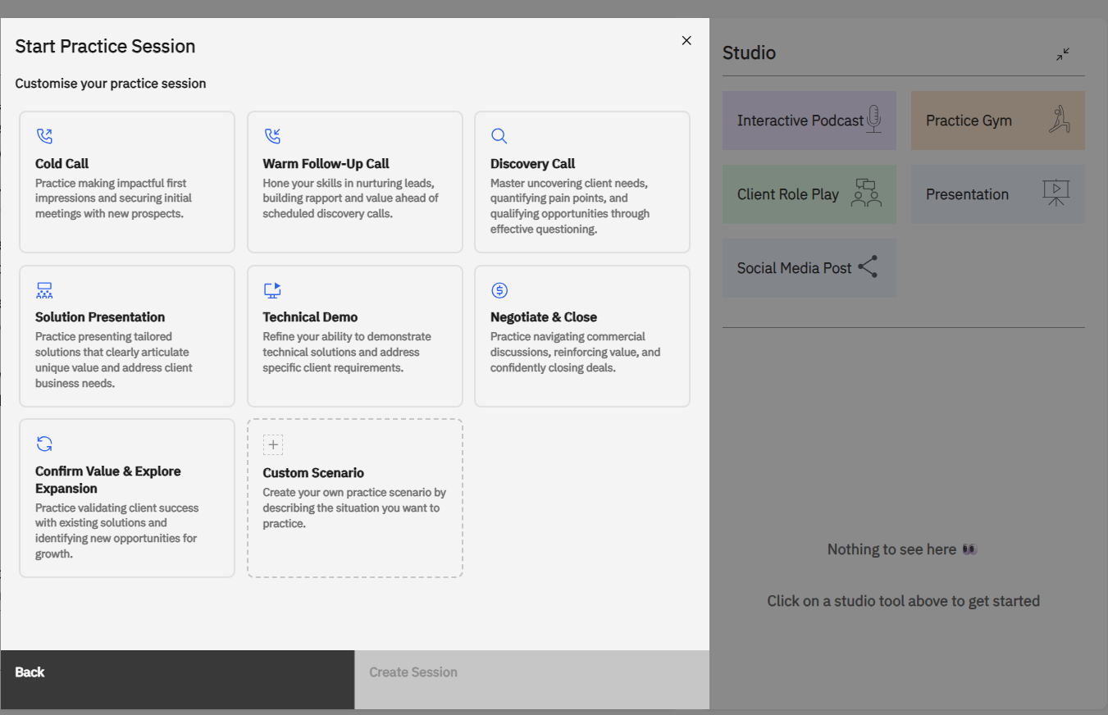
Includes usage of camera and back and forth conversation to simulate an actual call for clients
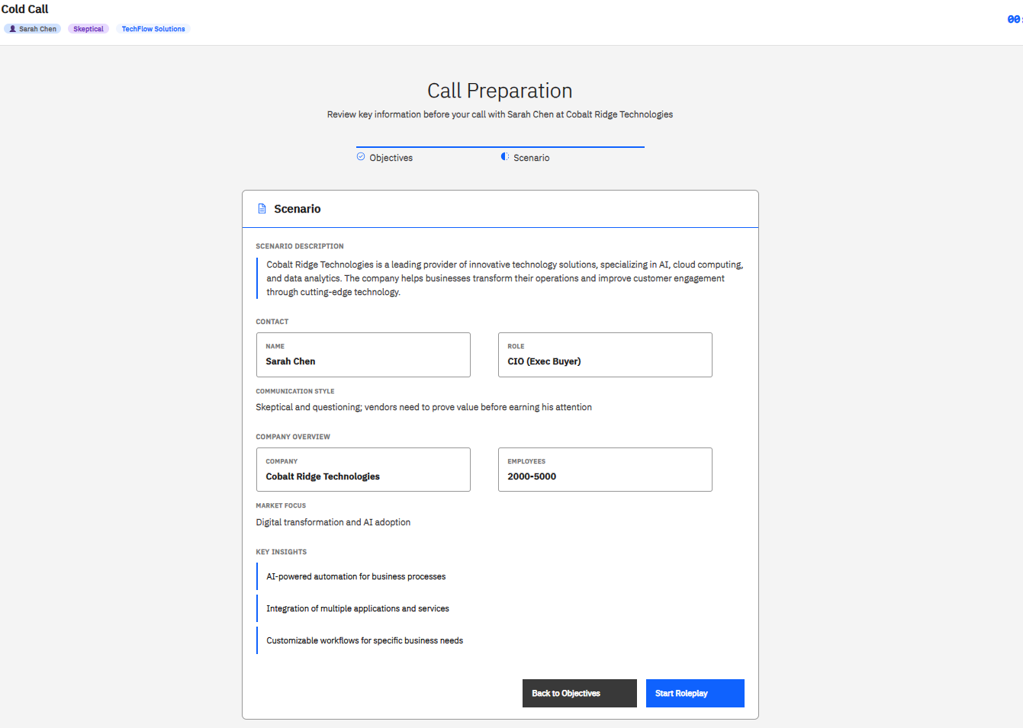
AskSales
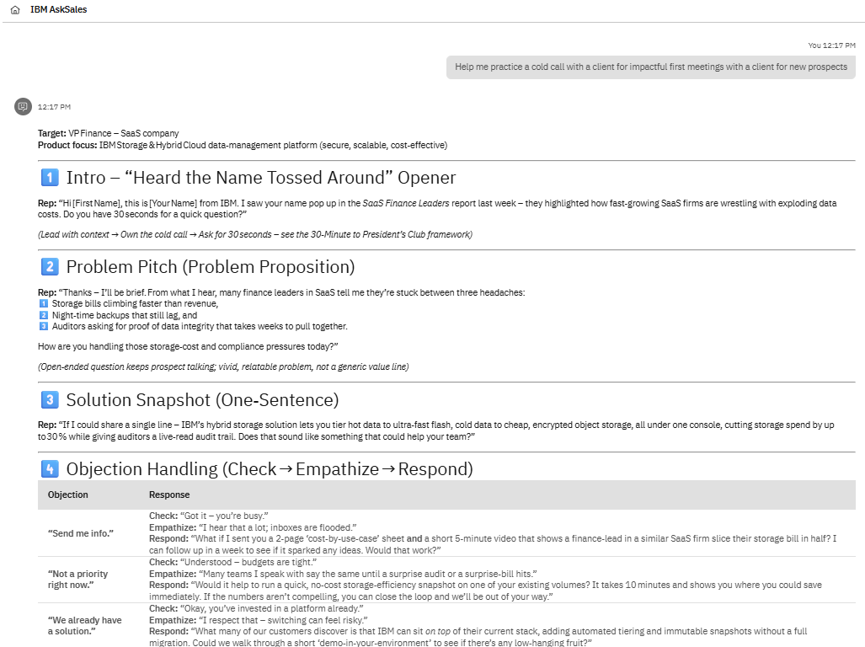
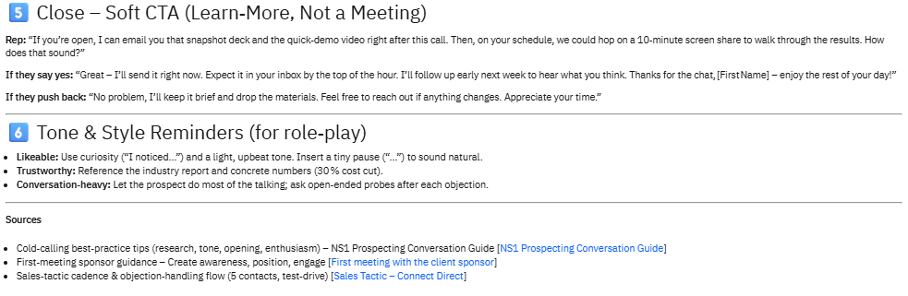

Comparison

watsonx.workshop
What it DOES well:
- Simulates real sales conversations and interactive
  - Back-and-forth interaction
  - Dynamic responses
- Persona-based (e.g., skeptical CFO)
- Provides feedback scoring
  - Helps improve delivery, confidence, structure
- Strong for:
  - Practicing objection handling
  - Testing pitch delivery
Limitations:
- Feedback is structured but not deeply strategic
  - e.g., may say “improve clarity” but not “wrong value prop”
- Scenarios feel generic, not account-specific
AskSales
What it does better:
- Helps craft:
  - exact responses to objections
  - key talking points
- More strategic in:
  - “What should I say?” vs. “How did I perform?”
Conclusion: watsonx.workshop = execution training; AskSales = messaging guidance

